Chapter 19, Problem 43.

Find the transmission parameters for the single-element two-port
networks in Fig.19.98.

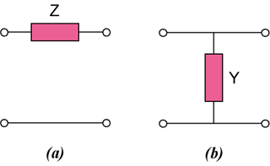

Figure 19.98
For Prob. 19.43.

